STM32F446RE Polling I²C Driver
Hardware-in-the-Loop Verification Report
Tests No. 1 to No. 9

Target | STM32F446RE
Peripheral | I2C1: PB6/SCL and PB7/SDA
Test device | DS3231 RTC, 7-bit address 0x68
Clocking | SYSCLK 180 MHz; APB1 45 MHz; I2C approximately 88 kHz
Environment | VS Code, Cortex-Debug, OpenOCD and ST-Link
Firmware style | CMSIS/register-level, polling, single execution context
Report revision | 0.3 - completed polling-driver Tests No. 1 to No. 9
Test date | 4-5 August 2026

This report consolidates the completed hardware-in-the-loop verification of the STM32F446RE polling I2C1 driver. It links each application-level test to the relevant driver path and records the debugger and hardware evidence obtained during Tests No. 1 to No. 9.

1. Executive summary
Nine hardware-in-the-loop tests have been completed against the polling I2C1 driver. The campaign covers recoverable address NACK handling, successful one-, two-, and N-byte receive paths, independent write/read managers, physical stuck-bus recovery, a 10,000-transfer stress run, and invalid-parameter rejection.
Test | Purpose | Principal path | Result
1 | Recoverable address NACK | AF/NACK → cleanup → READY | PASS
2 | Successful 1-byte combined read | i2c_receive_1_byte() | PASS
3 | Successful 7-byte combined read | i2c_receive_n_bytes() | PASS
4 | Successful 2-byte combined read | i2c_receive_2_bytes() | PASS
5 | Separate successful write and read | i2c_write() then i2c_read() | PASS
6 | Separate write/read address NACK | NACK cleanup twice; driver remains reusable | PASS
7 | Runtime recovery from forced SDA-low bus fault | ERROR → recover → READY → successful read | PASS
8 | 10,000-transfer stress test | Repeated i2c_write_read() endurance | PASS
9 | Invalid-parameter rejection | NULL pointer validation; state preserved | PASS
All completed tests passed. Successful transfers returned I2C_OK and restored I2C_STATE_READY. Recoverable NACK cases returned I2C_ERR_NACK while preserving reusability. The forced SDA-low test entered ERROR, rejected recovery while the fault remained, then returned to READY and completed a fresh RTC transaction after the fault was removed. The stress run completed 10,000 consecutive combined reads with zero errors, and all tested null-pointer requests returned I2C_ERR_PARAM without corrupting the driver state.

2. Verification architecture and common flow

2.1 Layering
- Application layer: main() calls the public driver API and records returned status/data in volatile debugger variables.
- Transaction manager: i2c_write_read() validates the request, acquires the software state, verifies physical bus admission, selects the receive helper, and decides the final state.
- Hardware workers: i2c_transmit_phase(), i2c_receive_1_byte(), i2c_receive_2_bytes(), i2c_receive_n_bytes(), and primitive register helpers implement the STM32F446 transaction sequence.

2.2 Common application-to-driver path
main()
|
+--> i2c_init(&i2c_config)
| +--> configure GPIO and I2C1 timing
| +--> establish ACK = 1, POS = 0
| +--> state = I2C_STATE_READY
|
+--> i2c_write_read(0x68, tx buffer, tx length, rx buffer, rx length)
+--> validate parameters
+--> require software state READY
+--> require SR2.BUSY = 0
+--> state = I2C_STATE_BUSY_TX_RX
+--> i2c_transmit_phase()
+--> choose receive helper from rx_length
+--> i2c_complete_transaction()
+--> READY on valid cleanup; ERROR on uncertain hardware state

2.3 Current combined transaction manager
Actual implementation from i2c_driver.c:
i2c_status_t i2c_write_read(
uint8_t address,
const uint8_t *p_tx_data,
uint16_t tx_length,
uint8_t *p_rx_data,
uint16_t rx_length)
{
i2c_status_t status;
/*----------------------------------------------------------
* 1. Parameter validation
*---------------------------------------------------------*/
if ((p_tx_data == NULL) ||
(p_rx_data == NULL) ||
(tx_length == 0U) ||
(rx_length == 0U) ||
(address > 0x7FU))
{
return I2C_ERR_PARAM;
}
/*----------------------------------------------------------
* 2. Acquire the complete combined transaction
*---------------------------------------------------------*/
switch (s_state)
{
case I2C_STATE_READY:
s_state = I2C_STATE_BUSY_TX_RX;
break;
case I2C_STATE_RESET:
return I2C_ERR_NOT_INIT;
case I2C_STATE_BUSY_RX:
case I2C_STATE_BUSY_TX:
case I2C_STATE_BUSY_TX_RX:
return I2C_ERR_BUSY;
case I2C_STATE_ERROR:
return I2C_ERR_LOCKED;
default:
return I2C_ERR_LOCKED;
}
/*----------------------------------------------------------
* 3. Write phase
*
* The helper returns after final BTF without STOP.
*---------------------------------------------------------*/
status = i2c_transmit_phase(
address,
p_tx_data,
tx_length);
if (status == I2C_OK)
{
/*
* The bus is still owned by I2C1.
*
* Each existing receive helper begins by setting START.
* Because MSL/BUSY remain asserted, that START becomes
* the required repeated START.
*/
if (rx_length == 1U)
{
status = i2c_receive_1_byte(
address,
p_rx_data);
}
else if (rx_length == 2U)
{
status = i2c_receive_2_bytes(
address,
p_rx_data);
}
else
{
status = i2c_receive_n_bytes(
address,
p_rx_data,
rx_length);
}
}
/*----------------------------------------------------------
* 4. Successful transaction completion
*---------------------------------------------------------*/
if (status == I2C_OK)
{
/*
* The selected receive helper has already requested
* STOP at the correct length-specific point.
*/
status = i2c_complete_transaction();
if (status == I2C_OK)
{
s_state = I2C_STATE_READY;
}
else
{
s_state = I2C_STATE_ERROR;
}
return status;
}
/*----------------------------------------------------------
* 5. Recoverable target NACK
*
* NACK can occur during:
* - Write address
* - Write payload
* - Read address after repeated START
*---------------------------------------------------------*/
if (status == I2C_ERR_NACK)
{
i2c_status_t cleanup_status;
/*
* i2c_abort_sequence() has already requested STOP
* if this controller still owns the bus.
*/
cleanup_status = i2c_complete_transaction();
if (cleanup_status == I2C_OK)
{
s_state = I2C_STATE_READY;
/* Preserve the original transaction result. */
return I2C_ERR_NACK;
}
/*
* The transaction NACK was recoverable, but the
* hardware teardown failed.
*/
s_state = I2C_STATE_ERROR;
return cleanup_status;
}
/*----------------------------------------------------------
* 6. Uncertain hardware state
*---------------------------------------------------------*/
s_state = I2C_STATE_ERROR;
return status;
}

3. Test No. 1 — Recoverable address NACK

3.1 Objective and setup
Verify that an electrically healthy bus with no target acknowledgement returns I2C_ERR_NACK, completes teardown, and returns the driver to READY.
Item | Value / interpretation
SCL | PB6 connected to RTC SCL
SDA | PB7 disconnected from RTC SDA
External pull-up | PB7/SDA pulled to 3.3 V through a resistor
Expected electrical condition | SCL and SDA high when idle
Expected software outcome | I2C_ERR_NACK with I2C_STATE_READY after cleanup

3.2 Application call
uint8_t register_address = DS3231_SECONDS_REGISTER;
uint8_t rtc_data[2] = {0U, 0U};
g_i2c_transfer_status = i2c_write_read(
DS3231_I2C_ADDRESS,
&register_address,
1U,
rtc_data,
2U);
g_i2c_state_after_transfer = i2c_get_state();

3.3 Decision path
main()
|
+--> i2c_write_read(0x68, ..., tx = 1, rx = 2)
|
+--> READY and SR2.BUSY = 0
+--> state = BUSY_TX_RX
+--> i2c_transmit_phase()
+--> START
+--> write address byte 0xD0
+--> wait for ADDR
+--> target does not ACK
+--> SR1.AF is detected
+--> AF is cleared
+--> I2C_ERR_NACK returned
|
+--> i2c_abort_sequence()
+--> terminate/request STOP
+--> i2c_complete_transaction()
+--> wait for STOP clear
+--> verify MSL = 0
+--> restore ACK = 1 and POS = 0
+--> state = READY
+--> preserve and return I2C_ERR_NACK

3.4 Relevant implementation functions
Error detection and flag polling:
static i2c_status_t i2c_wait_sr1_flag(uint32_t flag)
{
uint32_t timeout = I2C_TIMEOUT_COUNT;
while (timeout > 0U)
{
uint32_t sr1 = I2C1->SR1;
/*
* STM32F446 erratum:
* BERR may be spurious in controller mode.
* Clear it and continue processing the transaction.
*/
if ((sr1 & I2C_SR1_BERR) != 0U)
{
i2c_clear_error_flags(I2C_SR1_BERR);
sr1 &= ~I2C_SR1_BERR;
}
/* Genuine transaction errors take priority over success. */
if ((sr1 & I2C_SR1_ARLO) != 0U)
{
i2c_clear_error_flags(I2C_SR1_ARLO);
return I2C_ERR_BUS;
}
if ((sr1 & I2C_SR1_AF) != 0U)
{
i2c_clear_error_flags(I2C_SR1_AF);
return I2C_ERR_NACK;
}
if ((sr1 & I2C_SR1_OVR) != 0U)
{
i2c_clear_error_flags(I2C_SR1_OVR);
return I2C_ERR_BUS;
}
if ((sr1 & flag) == flag)
{
return I2C_OK;
}
timeout--;
}
return I2C_ERR_TIMEOUT;
}
Common completion and idle restoration:
static i2c_status_t i2c_complete_transaction(void)
{
uint32_t timeout = I2C_TIMEOUT_COUNT;
/* Wait until hardware has completed the STOP condition. */
while ((I2C1->CR1 & I2C_CR1_STOP) != 0U)
{
if (timeout == 0U)
{
return I2C_ERR_TIMEOUT;
}
timeout--;
}
/* Peripheral must no longer be controller/master. */
if ((I2C1->SR2 & I2C_SR2_MSL) != 0U)
{
return I2C_ERR_BUS;
}
/* Restore the defined idle receive configuration. */
i2c_enable_ack();
i2c_disable_pos();
return I2C_OK;
}

3.5 Observed evidence
Item | Value / interpretation
Initialization | I2C_OK; state after initialization = I2C_STATE_READY
Transfer status | I2C_ERR_NACK
State after transfer | I2C_STATE_READY
GPIOB->IDR & 0xC0 | 0xC0 (0b11000000): PB6/SCL high and PB7/SDA high
I2C1->SR2 | 0x0000 (0b0000000000000000): BUSY = 0, MSL = 0
I2C1->CR1 | 0x0401 (0b0000010000000001): PE = 1, ACK = 1, START/STOP/POS = 0

TEST NO. 1 RESULT: PASS — the NACK was reported while the driver and physical bus returned to a reusable idle condition.

4. Test No. 2 — Successful one-byte combined read

4.1 Objective
Verify the dedicated one-byte receive sequence, including ACK disable before ADDR clearing and immediate STOP programming.

4.2 Application call
uint8_t register_address = DS3231_SECONDS_REGISTER;
uint8_t rtc_data[1] = {0U};
g_i2c_transfer_status = i2c_write_read(
DS3231_I2C_ADDRESS,
&register_address,
1U,
rtc_data,
1U);
if (g_i2c_transfer_status == I2C_OK)
{
g_rtc_seconds_raw = rtc_data[0];
}
g_i2c_state_after_transfer = i2c_get_state();

4.3 Selected receive function
Actual one-byte implementation:
static i2c_status_t i2c_receive_1_byte(uint8_t address, uint8_t *p_data)
{
i2c_status_t status;
uint32_t primask_state;
/* 1. Force a known starting configuration */
i2c_enable_ack();
i2c_disable_pos();
/* 2. START Condition */
status = i2c_generate_start();
if (status != I2C_OK)
{
return i2c_abort_sequence(status);
}
/* 3. Send Address (Read Mode) */
status = i2c_send_address(address, 1U);
if (status != I2C_OK)
{
return i2c_abort_sequence(status);
}
/*----------------------------------------------------------
* 4. The Critical 1-Byte RM0390 Sequence
*---------------------------------------------------------*/
/* Disable ACK BEFORE clearing ADDR to force NACK on the 1st byte */
i2c_disable_ack();
/* ========================================== */
/* SAFE CRITICAL SECTION */
/* ========================================== */
primask_state = __get_PRIMASK();
__disable_irq();
/* Release the hardware to clock in the byte */
i2c_clear_addr_flag();
/* Program STOP immediately so it asserts after the byte arrives */
i2c_generate_stop();
/* Restore interrupts to their exact previous state */
__set_PRIMASK(primask_state);
/* ========================================== */
/*----------------------------------------------------------
* 5. Data Retrieval
*---------------------------------------------------------*/
status = i2c_receive_byte(p_data);
if (status != I2C_OK)
{
return i2c_abort_sequence(status);
}
return I2C_OK;
}

4.4 Decision path
main()
+--> i2c_write_read(..., rx_length = 1)
+--> i2c_transmit_phase()
+--> write register pointer 0x00
+--> retain bus ownership after BTF
+--> i2c_receive_1_byte()
+--> repeated START
+--> read address byte 0xD1
+--> ACK = 0 before ADDR clear
+--> critical section: clear ADDR then request STOP
+--> wait RXNE and read DR
+--> i2c_complete_transaction()
+--> state = READY
+--> return I2C_OK

4.5 Observed evidence
Item | Value / interpretation
Transfer status | I2C_OK
State after transfer | I2C_STATE_READY
Received seconds byte | 85 decimal = 0x55 = 0b01010101; BCD digits 5 and 5 = 55 seconds
GPIOB->IDR & 0xC0 | 0xC0
I2C1->SR2 | 0x0000
I2C1->CR1 | 0x0401

TEST NO. 2 RESULT: PASS — the one-byte receive path, STOP completion and state restoration were verified.

5. Test No. 3 — Successful N-byte combined read

5.1 Objective
Verify the rx_length > 2 branch by reading seven consecutive DS3231 registers. This test exercises the bulk RXNE loop and the final-three-byte BTF teardown sequence.

5.2 Application instrumentation and call
volatile uint8_t g_rtc_raw[7];
uint8_t register_address = DS3231_SECONDS_REGISTER;
uint8_t rtc_data[7] = {0U};
g_i2c_transfer_status = i2c_write_read(
DS3231_I2C_ADDRESS,
&register_address,
1U,
rtc_data,
7U);
if (g_i2c_transfer_status == I2C_OK)
{
for (uint32_t i = 0U; i < 7U; i++)
{
g_rtc_raw[i] = rtc_data[i];
}
}
g_i2c_state_after_transfer = i2c_get_state();

5.3 Manager branch and implementation path
Because rx_length equals seven, i2c_write_read() selects i2c_receive_n_bytes(). The write phase first places register 0x00 into the DS3231 address pointer without issuing STOP. The receive helper then generates the repeated START.
main()
|
+--> i2c_write_read(0x68, &register_address, 1, rtc_data, 7)
|
+--> i2c_transmit_phase()
| +--> START + 0xD0
| +--> transmit register 0x00
| +--> wait BTF; no STOP
|
+--> rx_length > 2
+--> i2c_receive_n_bytes()
+--> POS = 0; ACK = 1
+--> repeated START + 0xD1
+--> clear ADDR
+--> while length > 3: wait RXNE and read DR
+--> wait BTF with three bytes remaining
+--> ACK = 0
+--> read byte N-2
+--> wait BTF again
+--> request STOP
+--> read byte N-1
+--> wait RXNE and read byte N
|
+--> i2c_complete_transaction()
+--> state = READY
+--> return I2C_OK

5.4 Actual N-byte receive function
static i2c_status_t i2c_receive_n_bytes(uint8_t address, uint8_t *p_data, uint16_t length)
{
i2c_status_t status;
/* 1. Baseline Verification: Ensure standard NACK/POS state */
i2c_disable_pos(); /* CR1.POS = 0 */
i2c_enable_ack(); /* CR1.ACK = 1 */
/* 2. Initiate Bus Transaction */
status = i2c_generate_start();
if (status != I2C_OK) return i2c_abort_sequence(status);
/* 3. Transmit Slave Address with READ bit (LSB = 1) */
status = i2c_send_address(address, 1U);
if (status != I2C_OK) return i2c_abort_sequence(status);
/* 4. Release SCL to begin clocking data from the slave */
i2c_clear_addr_flag();
/* 5. Bulk Phase: Poll RXNE and read DR until 3 bytes remain */
while (length > 3U)
{
status = i2c_receive_byte(p_data); /* Helper: wait RXNE -> read DR */
if (status != I2C_OK) return i2c_abort_sequence(status);
p_data++;
length--;
}
/* =====================================================================
* 6. RM0390 Strict Teardown Phase for Final 3 Bytes
* ===================================================================== */
/*
* Handshake 1: Wait for BTF.
* Byte N-2 is in DR, Byte N-1 is in the Shift Register. SCL is stretched LOW.
*/
status = i2c_wait_sr1_flag(I2C_SR1_BTF);
if (status != I2C_OK) return i2c_abort_sequence(status);
/* Disable ACK so the hardware will NACK Byte N */
i2c_disable_ack();
/* Read Byte N-2. This clears BTF, releases SCL, and Byte N starts shifting in */
i2c_read_dr(p_data);
p_data++;
/*
* Handshake 2: Wait for BTF again.
* Byte N-1 is in DR, Byte N is in the Shift Register. SCL is stretched LOW again.
*/
status = i2c_wait_sr1_flag(I2C_SR1_BTF);
if (status != I2C_OK) return i2c_abort_sequence(status);
/* Program STOP bit while SCL is stretched. STOP fires after Byte N finishes */
i2c_generate_stop();
/* Read Byte N-1. This clears BTF and releases SCL for the STOP condition */
i2c_read_dr(p_data);
p_data++;
/*
* Final Byte Extraction: Byte N drops into DR.
* We use i2c_receive_byte() here to cleanly wait for RXNE and read the final byte.
*/
status = i2c_receive_byte(p_data);
if (status != I2C_OK) return i2c_abort_sequence(status);
return I2C_OK;
}

5.5 Debugger evidence
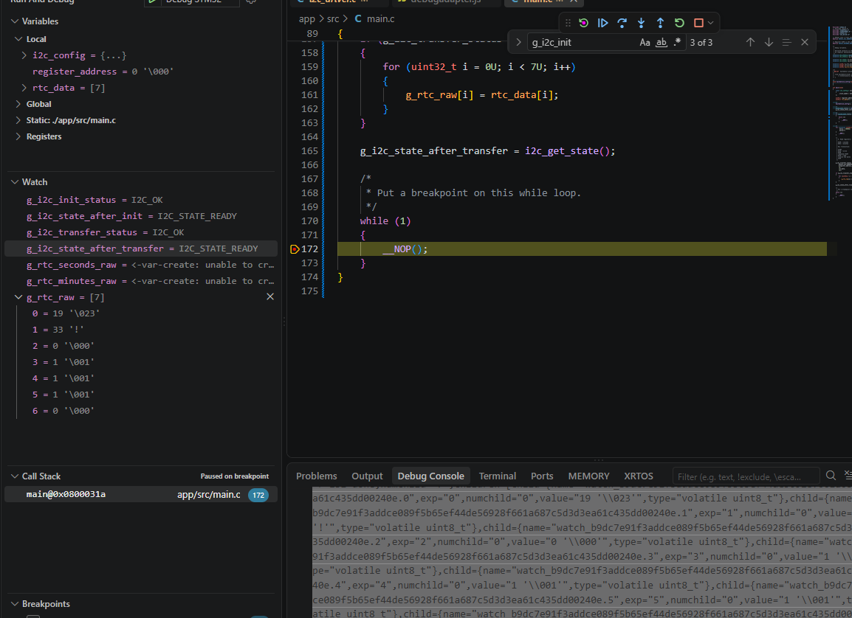
Figure 1. Test No. 3 final breakpoint. The Watch window records I2C_OK, I2C_STATE_READY and all seven received bytes.
Index | DS3231 register | Debugger decimal | Raw hex | Interpretation
0 | Seconds (0x00) | 19 | 0x13 | 13 seconds BCD
1 | Minutes (0x01) | 33 | 0x21 | 21 minutes BCD
2 | Hours (0x02) | 0 | 0x00 | 00 hours
3 | Day (0x03) | 1 | 0x01 | Day-of-week value 1
4 | Date (0x04) | 1 | 0x01 | Date value 1
5 | Month (0x05) | 1 | 0x01 | Month value 1
6 | Year (0x06) | 0 | 0x00 | Year value 00
The calendar fields were not compared against a deliberately programmed reference timestamp. They demonstrate coherent register reception, but this test does not by itself verify RTC calendar configuration or long-term timekeeping accuracy.
Item | Value / interpretation
Transfer status | I2C_OK
State after transfer | I2C_STATE_READY
Received length | 7 bytes
Primary proof | All seven array elements updated at the final breakpoint
Bus completion | The successful manager path completed and returned READY

TEST NO. 3 RESULT: PASS — the bulk RXNE loop and the final-three-byte BTF/ACK/STOP sequence completed successfully on hardware.

6. Test No. 4 — Successful two-byte combined read

6.1 Objective
Verify the dedicated STM32F4 two-byte receive sequence. This path uses POS = 1 and ACK = 0 before ADDR is cleared, waits for BTF, requests STOP, and then reads the two available bytes from DR.

6.2 Application instrumentation and call
volatile uint8_t g_rtc_two_raw[2];
uint8_t register_address = DS3231_SECONDS_REGISTER;
uint8_t rtc_data[2] = {0U, 0U};
g_i2c_transfer_status = i2c_write_read(
DS3231_I2C_ADDRESS,
&register_address,
1U,
rtc_data,
2U);
if (g_i2c_transfer_status == I2C_OK)
{
g_rtc_two_raw[0] = rtc_data[0];
g_rtc_two_raw[1] = rtc_data[1];
}
g_i2c_state_after_transfer = i2c_get_state();

6.3 Manager branch and implementation path
main()
|
+--> i2c_write_read(0x68, &register_address, 1, rtc_data, 2)
|
+--> i2c_transmit_phase()
| +--> START + 0xD0
| +--> write register pointer 0x00
| +--> wait BTF; retain bus ownership
|
+--> rx_length == 2
+--> i2c_receive_2_bytes()
+--> establish ACK = 1, POS = 0 baseline
+--> repeated START + 0xD1
+--> with ADDR set: POS = 1 and ACK = 0
+--> clear ADDR
+--> wait BTF: two bytes available
+--> request STOP
+--> read DR twice
|
+--> i2c_complete_transaction()
+--> wait STOP clear
+--> verify MSL = 0
+--> restore ACK = 1, POS = 0
+--> state = READY
+--> return I2C_OK

6.4 Actual two-byte receive function
static i2c_status_t i2c_receive_2_bytes(uint8_t address, uint8_t *p_data)
{
i2c_status_t status;
/* Establish a known receive configuration. */
i2c_enable_ack();
i2c_disable_pos();
/* Generate START and wait for SB. */
status = i2c_generate_start();
if (status != I2C_OK)
{
return i2c_abort_sequence(status);
}
/* Send 7-bit target address with read direction; wait for ADDR. */
status = i2c_send_address(address, 1U);
if (status != I2C_OK)
{
return i2c_abort_sequence(status);
}
/*
* ADDR is now set and SCL is held low.
* Configure the special two-byte receive behaviour
* before clearing ADDR.
*/
/* 2. THE FIX: Configure future hardware behavior while clock is paused */
i2c_enable_pos(); /* CR1.POS = 1 (NACK applies to the NEXT byte in shift register) */
i2c_disable_ack(); /* CR1.ACK = 0 */
/* 3. Release the clock by clearing ADDR. Hardware immediately shifts in 2 bytes. */
i2c_clear_addr_flag();
/*
* 4. Wait for BTF
*
* At BTF = 1:
* SCL is stretched low.
* DR = byte 1
* Shift register = byte 2
*---------------------------------------------------------*/
status = i2c_wait_sr1_flag(I2C_SR1_BTF);
if (status != I2C_OK)
{
return i2c_abort_sequence(status);
}
i2c_generate_stop();
/*----------------------------------------------------------
* 6. Extract Data (Blind read, no waiting)
BTF Guarantees (The hardware promises it's there): BTF stands for Byte Transfer Finished.
When this hardware flag turns on (1),
the internal silicon is telling me:
"The current data transfer is 100% complete and safely stored in the register
BTF guarantees both received bytes are available:
DR = byte 1
Shift register = byte 2
*---------------------------------------------------------*/
p_data[0] = (uint8_t)I2C1->DR;
p_data[1] = (uint8_t)I2C1->DR;
return I2C_OK;
}

6.5 Debugger and register evidence
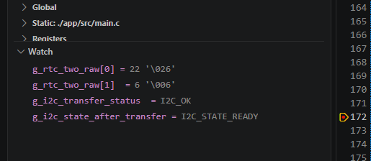
Figure 2. Test No. 4 final Watch values: two received bytes, I2C_OK and I2C_STATE_READY.
Item | Value / interpretation
g_rtc_two_raw[0] | 22 decimal = 0x16 = 0b00010110; BCD digits 1 and 6 = 16 seconds
g_rtc_two_raw[1] | 6 decimal = 0x06 = 0b00000110; BCD digits 0 and 6 = 06 minutes
g_i2c_transfer_status | I2C_OK
g_i2c_state_after_transfer | I2C_STATE_READY
GPIOB->IDR & 0xC0 | 0xC0 (0b11000000): SCL and SDA high
I2C1->SR2 | 0x0000 (0b0000000000000000): BUSY = 0, MSL = 0
I2C1->CR1 | 0x0401 (0b0000010000000001): PE and ACK set; START, STOP and POS clear

TEST NO. 4 RESULT: PASS — the dedicated POS/ACK two-byte sequence returned valid DS3231 data and left both the peripheral and driver in the defined idle state.

7. Interim conclusions after Tests No. 1–4
- The public i2c_write_read() manager correctly selects receive_1_byte, receive_2_bytes or receive_n_bytes from rx_length.
- The repeated-START architecture works because i2c_transmit_phase() returns after final BTF without generating STOP.
- A clean address NACK is preserved as I2C_ERR_NACK while successful cleanup returns the state to READY.
- The one-byte path correctly applies ACK disable before ADDR clearing and programs STOP in the protected sequence.
- The N-byte path successfully executes both the bulk RXNE phase and the final-three-byte BTF sequence.
- The two-byte path successfully uses POS/ACK configuration, BTF, STOP and two DR reads.
- Successful transactions leave SCL and SDA high, SR2 clear, CR1 at 0x0401 and the software state at I2C_STATE_READY.

7.1 Status at the end of the first test group
Item | Value / interpretation
Test No. 1 | PASS — recoverable address NACK
Test No. 2 | PASS — one-byte combined read
Test No. 3 | PASS — seven-byte/N-byte combined read
Test No. 4 | PASS — two-byte combined read
Next planned activity | Test No. 5: separate public i2c_write() and i2c_read() calls

This report records functional branch coverage on real hardware. It does not yet constitute timing-margin, EMC, multi-controller arbitration, long-duration stress, or formal requirements-based coverage.

8. Number representation used in the evidence
The VS Code Watch window normally displays uint8_t values in decimal and may also show the corresponding ASCII character. The report therefore gives important values in decimal, hexadecimal and binary. DS3231 time registers use binary-coded decimal (BCD), so the upper four bits represent the tens digit and the lower four bits represent the units digit.
Item | Observed value / interpretation
Example RTC byte | 71 decimal = 0x47 = 0b01000111
BCD interpretation | Upper nibble 0100 = digit 4; lower nibble 0111 = digit 7; result = 47 seconds
7-bit DS3231 address | 0x68 = 0b1101000 (or 0b01101000 when shown in an 8-bit field)
Transmitted write address | 0xD0 = 0b11010000
Transmitted read address | 0xD1 = 0b11010001
Idle GPIO mask | 0xC0 = 0b11000000: PB7 and PB6 both high
Idle I2C CR1 | 0x0401 = 0b0000010000000001: ACK bit 10 and PE bit 0 set
Idle I2C SR2 | 0x0000 = 0b0000000000000000: MSL and BUSY clear

9. Test No. 5 — Separate successful i2c_write() and i2c_read()

9.1 Objective
Verify the two public transaction managers independently. The first transaction writes DS3231 register pointer 0x00 and terminates with STOP. The second transaction begins with a new START and reads one byte. This is intentionally different from i2c_write_read(), which retains bus ownership and uses a repeated START.

9.2 Application call
uint8_t register_address = DS3231_SECONDS_REGISTER;
uint8_t read_data = 0U;
/* Transaction A: write the DS3231 internal register pointer. */
g_write_status = i2c_write(
DS3231_I2C_ADDRESS,
&register_address,
1U);
g_state_after_write = i2c_get_state();
/* Transaction B: a completely separate one-byte read. */
g_read_status = i2c_read(
DS3231_I2C_ADDRESS,
&read_data,
1U);
g_state_after_read = i2c_get_state();
if (g_read_status == I2C_OK)
{
g_separate_read_data = read_data;
}

9.3 Application-to-driver decision path
main()
|
+--> i2c_write(0x68, &register_address, 1)
| +--> validate parameters
| +--> READY -> BUSY_TX
| +--> i2c_transmit_phase()
| +--> START
| +--> DR = 0xD0 (0b11010000)
| +--> clear ADDR
| +--> transmit register 0x00
| +--> wait final BTF
| +--> generate STOP
| +--> i2c_complete_transaction()
| +--> READY; return I2C_OK
|
+--> i2c_read(0x68, &read_data, 1)
+--> validate parameters
+--> READY -> BUSY_RX
+--> select i2c_receive_1_byte()
+--> new START
+--> DR = 0xD1 (0b11010001)
+--> one-byte ACK/ADDR/STOP sequence
+--> read DR
+--> i2c_complete_transaction()
+--> READY; return I2C_OK

9.4 Actual public manager functions
Current i2c_write() implementation:
i2c_status_t i2c_write(uint8_t address,
const uint8_t *p_data,
uint16_t length)
{
i2c_status_t status;
/*----------------------------------------------------------
* 1. Parameter validation
*---------------------------------------------------------*/
if ((p_data == NULL) ||
(length == 0U) ||
(address > 0x7FU))
{
return I2C_ERR_PARAM;
}
/*----------------------------------------------------------
* 2. Acquire driver ownership
*
* V1 contract:
* - Polling
* - Single execution context
* - Not reentrant
* - Must not be called from an ISR
*---------------------------------------------------------*/
switch (s_state)
{
case I2C_STATE_READY:
s_state = I2C_STATE_BUSY_TX;
break;
case I2C_STATE_RESET:
return I2C_ERR_NOT_INIT;
case I2C_STATE_BUSY_RX:
case I2C_STATE_BUSY_TX:
return I2C_ERR_BUSY;
case I2C_STATE_ERROR:
return I2C_ERR_LOCKED;
default:
return I2C_ERR_LOCKED;
}
/*----------------------------------------------------------
* 3. Execute the controller-transmitter sequence
*---------------------------------------------------------*/
status = i2c_transmit_phase(address, p_data, length);
if (status == I2C_OK)
{
/*
* Pure write transaction: terminate after final BTF.
*/
i2c_generate_stop();
}
/*----------------------------------------------------------
* 4. Successful hardware completion
*---------------------------------------------------------*/
if (status == I2C_OK)
{
/*
* The sequence helper has requested STOP after BTF.
* Verify that STOP completed before releasing the
* software state.
*/
status = i2c_complete_transaction();
if (status == I2C_OK)
{
s_state = I2C_STATE_READY;
}
else
{
s_state = I2C_STATE_ERROR;
}
return status;
}
/*----------------------------------------------------------
* 5. Recoverable transaction failure: target NACK
*---------------------------------------------------------*/
if (status == I2C_ERR_NACK)
{
i2c_status_t cleanup_status;
/*
* i2c_abort_sequence() has already requested STOP
* when this peripheral still owned the bus.
*/
cleanup_status = i2c_complete_transaction();
if (cleanup_status == I2C_OK)
{
/*
* The controller is healthy and reusable.
* Preserve the original transaction result.
*/
s_state = I2C_STATE_READY;
return I2C_ERR_NACK;
}
/*
* The NACK itself was recoverable, but bus teardown
* failed. Report the cleanup failure because the
* hardware state can no longer be trusted.
*/
s_state = I2C_STATE_ERROR;
return cleanup_status;
}
/*----------------------------------------------------------
* 6. Unrecoverable or currently unclassified failure
*---------------------------------------------------------*/
s_state = I2C_STATE_ERROR;
return status;
}
Current i2c_read() implementation:
i2c_status_t i2c_read(uint8_t address, uint8_t *p_data, uint16_t length)
{
i2c_status_t status;
/* 1. Parameter Validation */
if (p_data == NULL || length == 0U || address > 0x7FU)
{
return I2C_ERR_PARAM;
}
/* 2. State Gatekeeping */
switch (s_state)
{
case I2C_STATE_READY:
/* Safe to proceed, lock the state for the current operation */
s_state = I2C_STATE_BUSY_RX;
break;
case I2C_STATE_ERROR:
return I2C_ERR_LOCKED;
case I2C_STATE_RESET:
return I2C_ERR_NOT_INIT;
case I2C_STATE_BUSY_RX:
case I2C_STATE_BUSY_TX:
case I2C_STATE_BUSY_TX_RX:
return I2C_ERR_BUSY;
default:
return I2C_ERR_LOCKED;
}
/* 3. Dispatch to Specific RM0390 Hardware Sequence Helpers */
if (length == 1U)
{
status = i2c_receive_1_byte(address, p_data);
}
else if (length == 2U)
{
status = i2c_receive_2_bytes(address, p_data);
}
else
{
status = i2c_receive_n_bytes(address, p_data, length);
}
/* 4. Strict State Lifecycle Enforcement */
if (status == I2C_OK)
{
/*
* Normal successful transaction:
* verify STOP completion and restore idle configuration.
*/
status = i2c_complete_transaction();
if (status == I2C_OK)
{
s_state = I2C_STATE_READY;
}
else
{
s_state = I2C_STATE_ERROR;
}
}
else if (status == I2C_ERR_NACK)
{
i2c_status_t cleanup_status;
/*
* The sequence abort function has already requested STOP.
* Complete the bus teardown before allowing another transaction.
*/
cleanup_status = i2c_complete_transaction();
if (cleanup_status == I2C_OK)
{
s_state = I2C_STATE_READY;
/* Preserve the original transaction result. */
return I2C_ERR_NACK;
}
/*
* NACK recovery itself failed, so the hardware state
* can no longer be trusted.
*/
status = cleanup_status;
s_state = I2C_STATE_ERROR;
}
else
{
/*
* Timeout, bus error, overrun, or arbitration-related
* failures remain locked until proper recovery.
*/
s_state = I2C_STATE_ERROR;
}
return status;
}

9.5 Debugger and register evidence
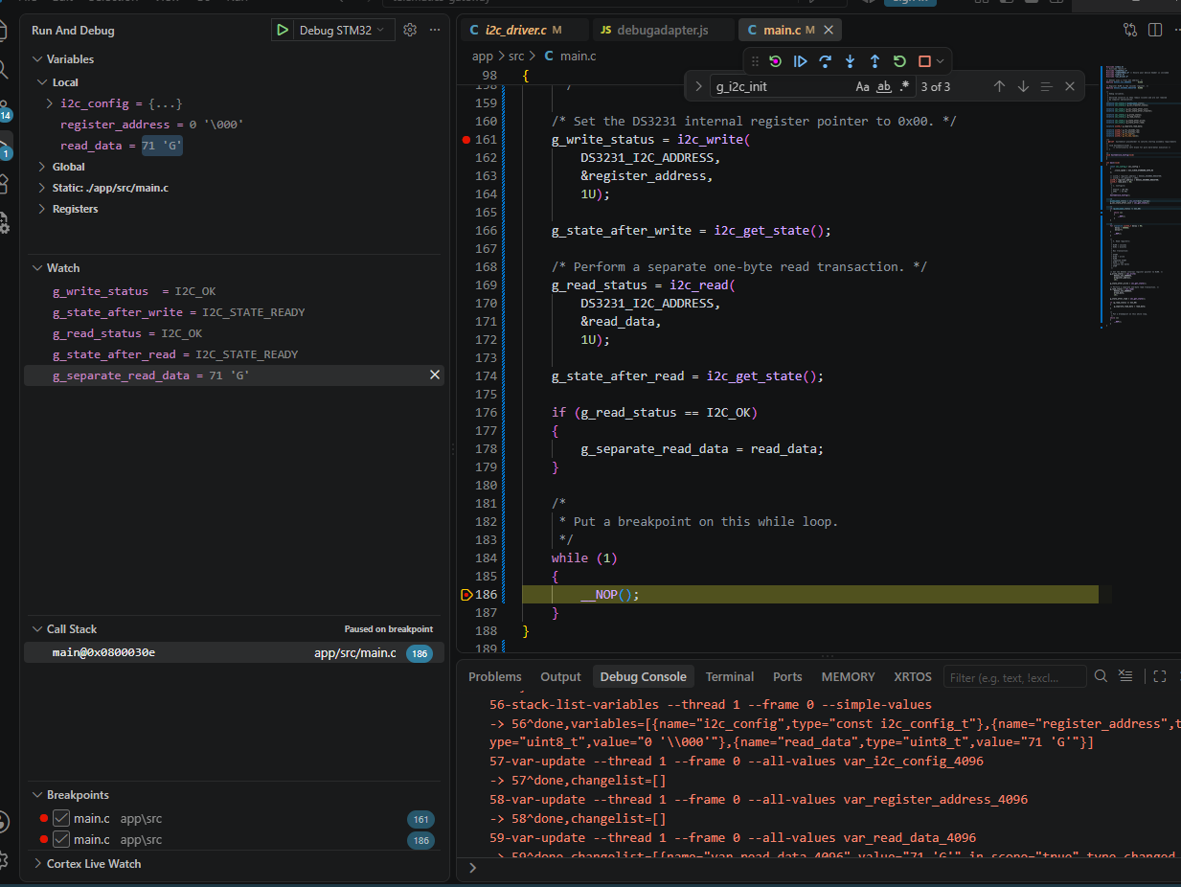
Figure 3. Test No. 5 at the final breakpoint: both public calls returned I2C_OK, both recorded states are READY, and the standalone read returned the DS3231 seconds byte.
Item | Observed value / interpretation
g_write_status | I2C_OK
g_state_after_write | I2C_STATE_READY
g_read_status | I2C_OK
g_state_after_read | I2C_STATE_READY
g_separate_read_data | 71 decimal = 0x47 = 0b01000111; BCD digits 4 and 7 = 47 seconds
GPIOB->IDR & 0xC0 | 0xC0 = 0b11000000: PB7/SDA and PB6/SCL high
I2C1->SR2 | 0x0000 = 0b0000000000000000: BUSY = 0 and MSL = 0
I2C1->CR1 | 0x0401 = 0b0000010000000001: ACK and PE set; START, STOP and POS clear

TEST NO. 5 RESULT: PASS — i2c_write() and i2c_read() each completed as an independent transaction, each released the bus, and each returned the driver to READY.

10. Test No. 6 — Separate write/read address-NACK recovery

10.1 Objective and hardware condition
Verify the recoverable NACK branch in both public managers. RTC SDA was disconnected while PB7 remained pulled high through the external resistor. The bus was therefore electrically idle, but the DS3231 could not acknowledge either address phase.
Item | Observed value / interpretation
PB6/SCL | Connected to the RTC and pulled high
PB7/SDA | Disconnected from RTC SDA
PB7 pull-up | External resistor to 3.3 V
Expected write result | I2C_ERR_NACK followed by I2C_STATE_READY
Expected read result | I2C_ERR_NACK followed by I2C_STATE_READY
Important proof | The second API call must still be admitted after the first NACK

10.2 Application call
/* Same application sequence as Test No. 5. */
g_write_status = i2c_write(
DS3231_I2C_ADDRESS,
&register_address,
1U);
g_state_after_write = i2c_get_state();
g_read_status = i2c_read(
DS3231_I2C_ADDRESS,
&read_data,
1U);
g_state_after_read = i2c_get_state();
if (g_read_status == I2C_OK)
{
g_separate_read_data = read_data;
}

10.3 Decision path
i2c_write()
|
+--> START + write address 0xD0
+--> no target ACK -> SR1.AF
+--> i2c_wait_sr1_flag() returns I2C_ERR_NACK
+--> abort/STOP cleanup
+--> i2c_complete_transaction()
+--> state = READY
+--> application receives I2C_ERR_NACK
|
v
i2c_read() is admitted because the state is READY
|
+--> START + read address 0xD1
+--> no target ACK -> SR1.AF
+--> I2C_ERR_NACK
+--> abort/STOP cleanup
+--> i2c_complete_transaction()
+--> state = READY
+--> application receives I2C_ERR_NACK

10.4 Debugger and register evidence
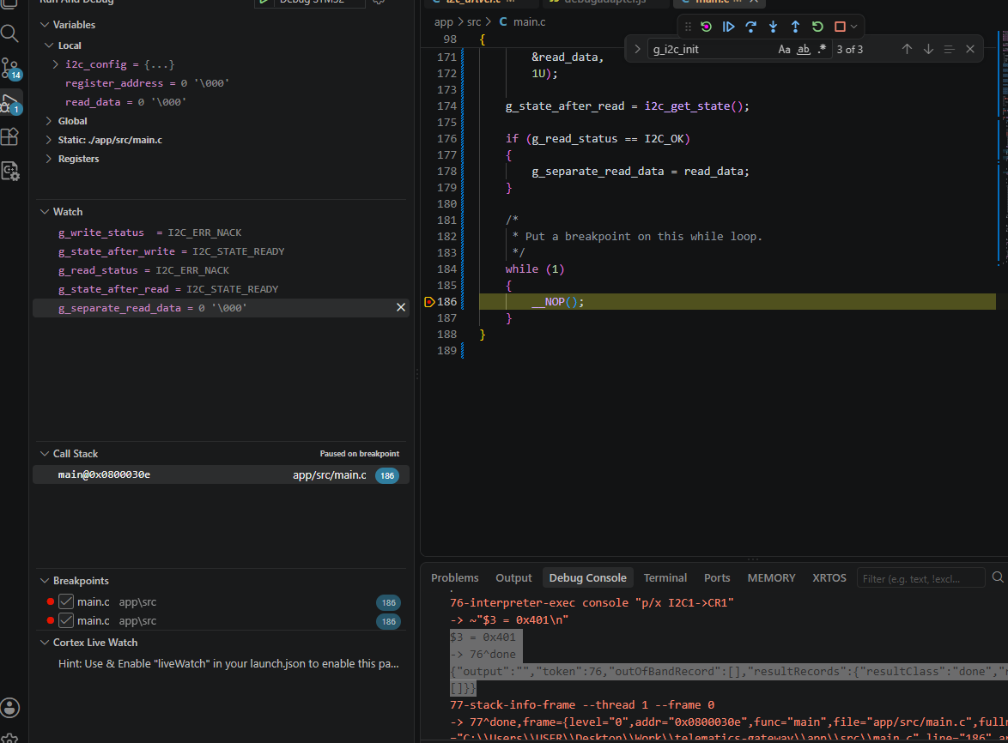
Figure 4. Test No. 6 at the final breakpoint: both public calls returned I2C_ERR_NACK, but the state after each call is I2C_STATE_READY.
Item | Observed value / interpretation
g_write_status | I2C_ERR_NACK
g_state_after_write | I2C_STATE_READY
g_read_status | I2C_ERR_NACK
g_state_after_read | I2C_STATE_READY
g_separate_read_data | 0 decimal = 0x00 = 0b00000000; copy block correctly skipped
GPIOB->IDR & 0xC0 | 0xC0 = 0b11000000: both physical lines high
I2C1->SR2 | 0x0000 = 0b0000000000000000: BUSY and MSL clear
I2C1->CR1 | 0x0401 = 0b0000010000000001: peripheral idle configuration restored

TEST NO. 6 RESULT: PASS — a write-address NACK did not lock the driver; the subsequent read was admitted, also reported NACK correctly, and again returned READY.

11. Functional verification summary through Test No. 7
Test | Verified behaviour | Final state | Result
1 | Combined-call address NACK and recoverable cleanup | READY | PASS
2 | Successful one-byte combined read | READY | PASS
3 | Successful N-byte/seven-byte combined read | READY | PASS
4 | Successful two-byte combined read | READY | PASS
5 | Separate successful i2c_write() and i2c_read() | READY after each | PASS
6 | Separate write/read address NACK recovery | READY after each | PASS
7 | Runtime recovery from forced SDA-low bus fault | ERROR → recover → READY → successful read | PASS
The principal transaction branches, recoverable NACK behaviour and runtime recovery from the ERROR state have now been demonstrated on hardware without resetting or power-cycling the microcontroller. Remaining work concerns waveform timing, automated regression, stress testing and API-negative coverage rather than the core transaction flow.

12. Test No. 7 — Runtime recovery verification method

12.1 Controlled-fault test procedure
This procedure verifies the recovery API by forcing a genuine non-idle/stuck-bus condition so a transaction returns I2C_ERR_BUS and the state becomes I2C_STATE_ERROR. The fault is then removed, i2c_recover() is called without resetting the MCU, and a subsequent RTC transaction is used as the end-to-end recovery proof.
Normal initialization
|
+--> deliberately hold SDA low
+--> transaction returns I2C_ERR_BUS
+--> state = I2C_STATE_ERROR
|
+--> release SDA so SCL = SDA = high
+--> call i2c_recover()
+--> peripheral RCC reset/reconfiguration
+--> verify SR2.BUSY = 0
+--> state = I2C_STATE_READY
|
+--> perform a fresh RTC read
+--> I2C_OK
+--> valid data
+--> READY
- This test must be completed without monitor reset, power cycling or restarting the debug session between the induced fault and i2c_recover().
- After Test No. 7, convert the manual cases into an automated regression test application.
- Then capture SCL/SDA with a logic analyser to verify actual clock rate, repeated START, ACK/NACK placement and STOP timing.
- Finally, add long-duration repeated-transaction testing and parameter/state negative tests.

12.2 Recovery function under verification
The following public function was exercised by Test No. 7. The test verifies that this path restores the driver after a genuine ERROR condition without an MCU reset.
i2c_status_t i2c_recover(void)
{
i2c_status_t status;
/*
* Recovery requires a configuration from a previously
* successful initialization.
*/
if ((s_state == I2C_STATE_RESET) ||
(s_config_valid == 0U))
{
return I2C_ERR_NOT_INIT;
}
/*
* Never reset the peripheral underneath an active
* transaction.
*/
if ((s_state == I2C_STATE_BUSY_RX) ||
(s_state == I2C_STATE_BUSY_TX))
{
return I2C_ERR_BUSY;
}
// an already healthy driver requires no recovery.
if (s_state == I2C_STATE_READY)
{
return I2C_OK;
}
/*
* Only ERROR reaches the actual recovery operation.
* Keep the state as ERROR throughout recovery so no
* transaction can be admitted prematurely.
*/
if (s_state != I2C_STATE_ERROR)
{
return I2C_ERR_LOCKED;
}
/*
* Clocks and GPIO remain configured from i2c_init().
* Reset and reconfigure only the I2C1 peripheral.
*/
status = i2c_reset_and_configure_peripheral(&s_config);
if (status != I2C_OK)
{
s_state = I2C_STATE_ERROR;
return status;
}
/*
* Peripheral recovery succeeded, but the physical bus
* must also be available before the driver becomes READY.
*
* In this V1 single-controller design, persistent BUSY
* indicates that SDA or SCL may still be held low.
*/
if ((I2C1->SR2 & I2C_SR2_BUSY) != 0U)
{
s_state = I2C_STATE_ERROR;
return I2C_ERR_BUS;
}
s_state = I2C_STATE_READY;
return I2C_OK;
}

12.3 Planned activities after runtime recovery verification
Activity | Purpose | Required evidence
Automated regression application | Run Tests 1–7 from a repeatable firmware harness rather than manual code edits. | Timestamped pass/fail counters and captured final states.
Logic-analyser validation | Verify actual SCL frequency, START/repeated START, ACK/NACK and STOP placement. | Saved waveform captures with measured timing.
Stress and endurance | Detect intermittent state, timeout or cleanup failures over many transactions. | At least thousands of successful iterations with zero unexpected locks.
Negative/API tests | Verify null pointers, zero lengths, invalid addresses, NOT_INIT, BUSY and LOCKED returns. | Requirements-linked test cases and expected status values.

13. Test No. 7 — Executed runtime i2c_recover() verification

13.1 Objective
Verify that a genuine physical bus fault drives the software state to ERROR, that recovery is rejected while the fault remains, and that i2c_recover() restores the driver after SDA is released. The final proof is a successful DS3231 transaction without an MCU reset, debugger restart or power cycle.

13.2 Controlled hardware sequence
Item | Observed value / interpretation
Normal wiring | PB6/SCL and PB7/SDA connected to the powered DS3231 module.
Fault injection | At Breakpoint A, PB7/SDA was temporarily connected to GND through 1 kΩ.
Fault-stage expectation | Transaction returns I2C_ERR_BUS and state becomes I2C_STATE_ERROR.
Recovery while faulted | i2c_recover() must return I2C_ERR_BUS and state must remain ERROR.
Fault removal | At Breakpoint B, the temporary 1 kΩ-to-GND connection was removed; RTC SDA remained connected.
Recovery proof | i2c_recover() returns I2C_OK, state becomes READY, then a new DS3231 transaction returns I2C_OK.
Excluded run | The earlier accidental PB7 pull-up to 5 V was not used as formal verification evidence.

13.3 Application-level test sequence
/* Stage A: force SDA low before continuing. */
g_recovery_test_stage = 1U;
__NOP();
g_fault_transfer_status = i2c_write_read(
DS3231_I2C_ADDRESS,
&register_address,
1U,
rtc_data,
2U);
g_state_after_fault = i2c_get_state();
/* Recovery must fail while SDA remains held low. */
g_recover_while_stuck_status = i2c_recover();
g_state_after_failed_recover = i2c_get_state();
/* Stage B: remove the temporary SDA-to-GND connection. */
g_recovery_test_stage = 2U;
__NOP();
/* Recover without resetting the MCU. */
g_recover_after_release_status = i2c_recover();
g_state_after_successful_recover = i2c_get_state();
/* Prove the recovered driver can transact normally. */
g_post_recovery_transfer_status = i2c_write_read(
DS3231_I2C_ADDRESS,
&register_address,
1U,
rtc_data,
2U);
if (g_post_recovery_transfer_status == I2C_OK)
{
g_post_recovery_data[0] = rtc_data[0];
g_post_recovery_data[1] = rtc_data[1];
}
g_state_after_post_recovery_transfer = i2c_get_state();

13.4 Decision and state path
Normal initialization
|
+--> state = READY
|
+--> SDA forced low through 1 kΩ
|
+--> i2c_write_read()
| +--> physical bus is not available
| +--> return I2C_ERR_BUS
| +--> state = ERROR
|
+--> i2c_recover() while SDA remains low
| +--> reset/reconfigure I2C1
| +--> physical bus still unavailable
| +--> return I2C_ERR_BUS
| +--> remain ERROR
|
+--> remove temporary SDA-to-GND connection
+--> confirm PB6/PB7 high: IDR mask = 0xC0
|
+--> i2c_recover()
| +--> reset/reconfigure I2C1
| +--> bus available
| +--> state = READY
| +--> return I2C_OK
|
+--> fresh i2c_write_read()
+--> return I2C_OK
+--> valid RTC data copied
+--> final state = READY

13.5 Fault-stage debugger evidence
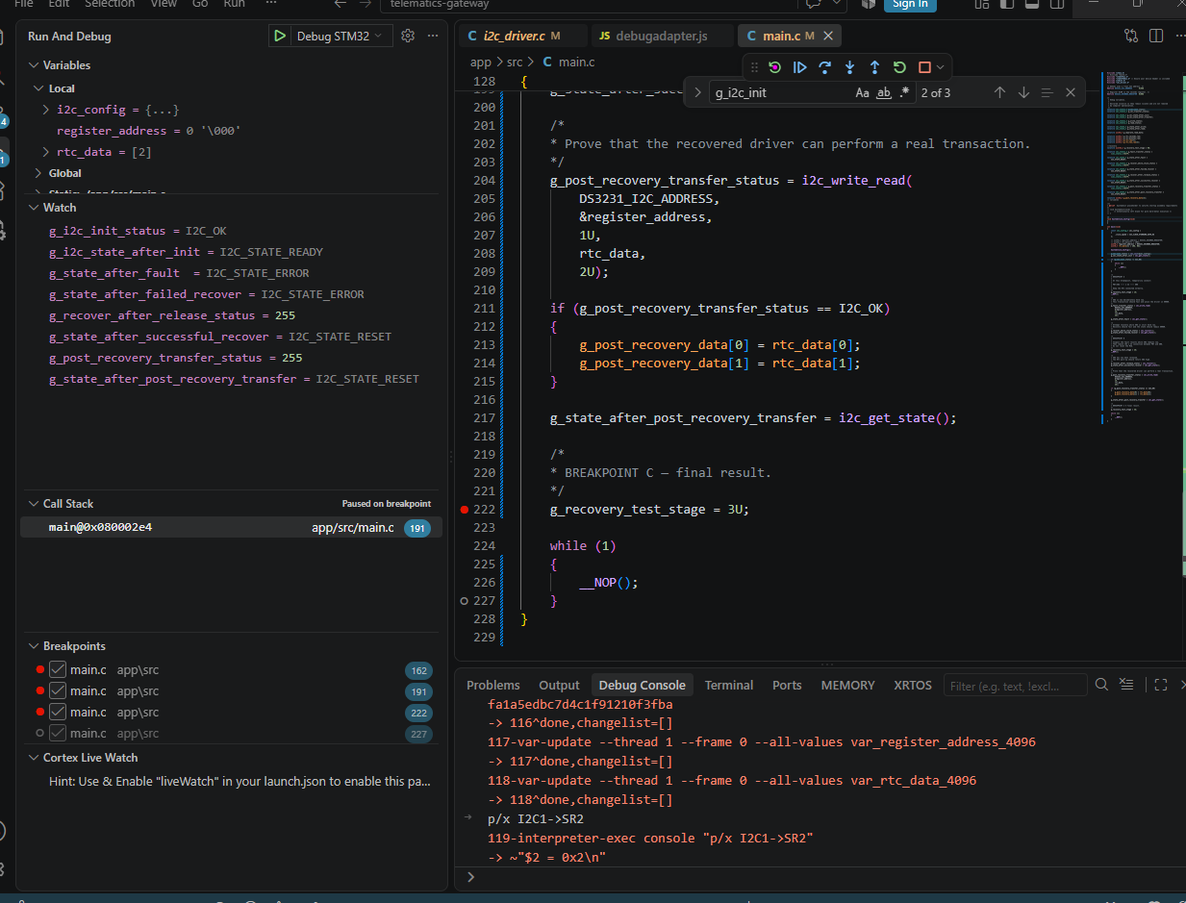
Figure 5. Fault stage: the transaction has placed the driver in I2C_STATE_ERROR and the first recovery attempt remains in ERROR while SDA is held low.
Item | Observed value / interpretation
g_state_after_fault | I2C_STATE_ERROR
g_state_after_failed_recover | I2C_STATE_ERROR
GPIOB->IDR & 0xC0 | 0x40 = 0b01000000: PB6/SCL high, PB7/SDA low
I2C1->SR2 during fault | 0x02 = 0b0000000000000010: BUSY set

13.6 Final recovery and post-recovery evidence
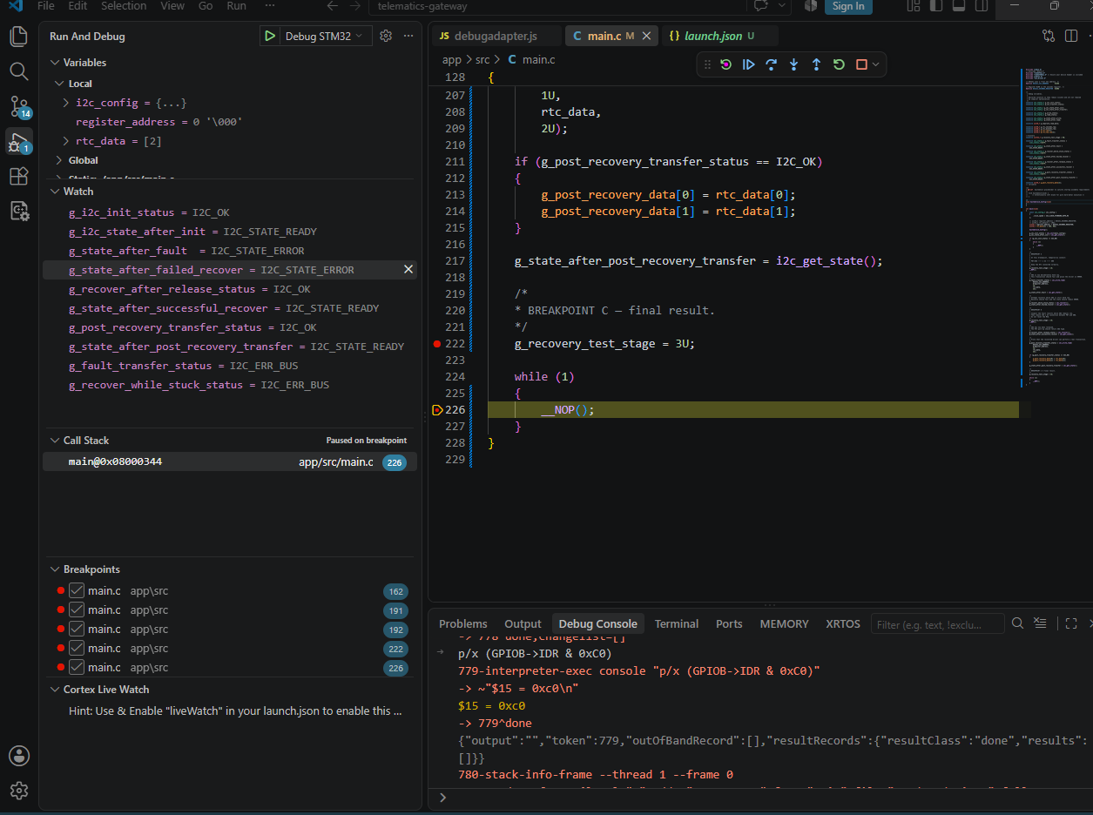
Figure 6. Final Test No. 7 result at the last breakpoint: fault detection, failed recovery while stuck, successful recovery after release, and a successful post-recovery transaction.
Item | Observed value / interpretation
g_fault_transfer_status | I2C_ERR_BUS
g_state_after_fault | I2C_STATE_ERROR
g_recover_while_stuck_status | I2C_ERR_BUS
g_state_after_failed_recover | I2C_STATE_ERROR
g_recover_after_release_status | I2C_OK
g_state_after_successful_recover | I2C_STATE_READY
g_post_recovery_transfer_status | I2C_OK
g_state_after_post_recovery_transfer | I2C_STATE_READY
GPIOB->IDR & 0xC0 after release | 0xC0 = 0b11000000: PB7/SDA and PB6/SCL both high

The final screenshot was captured at the last breakpoint. It records all software status/state values from the full sequence. The GPIO input measurement confirms that the physical bus lines were high before the successful recovery and post-recovery transaction. A separate final SR2/CR1 register capture was not included in this screenshot; therefore the formal conclusion relies on the successful post-recovery transaction and the final READY state.
TEST NO. 7 RESULT: PASS — a forced SDA-low fault produced I2C_ERR_BUS and ERROR; recovery was rejected while the fault remained; after SDA release, i2c_recover() returned I2C_OK and a fresh RTC transaction completed successfully with the driver in READY.

14. Functional HIL coverage through Test No. 7
Test | Verified behaviour | Final software state | Result
1 | Recoverable address NACK in combined transaction | READY | PASS
2 | Successful one-byte combined read | READY | PASS
3 | Successful N-byte/seven-byte combined read | READY | PASS
4 | Successful two-byte combined read | READY | PASS
5 | Separate successful i2c_write() and i2c_read() | READY after each | PASS
6 | Separate write/read address-NACK recovery | READY after each | PASS
7 | Runtime recovery from forced SDA-low fault | ERROR → READY | PASS

15. Verification extensions after Test No. 7
Following the runtime-recovery test, two additional transition tests were completed: a 10,000-transfer stress run and an invalid-parameter test. These close the most important polling-driver verification gaps before the interrupt-driven implementation begins.
- A logic-analyser capture was prepared but was not accepted as completed evidence in this test campaign. It is therefore not counted as a passed test. Electrical protocol timing verification remains a future enhancement rather than a prerequisite for starting the interrupt-driven software implementation.
- The repeated-transfer objective was completed by Test No. 8 with 10,000 consecutive combined reads.
- The first endurance milestone was completed; further hot-disconnect and SCL-low injection can be added later.
- The required null-pointer validation cases were completed by Test No. 9.
- The next software activity is the interrupt-driven I2C1 driver, retaining this polling implementation as the reference baseline.
- Freeze and tag this polling driver before creating the interrupt-driven branch.

15.1 Status of the polling baseline
The polling implementation is functionally verified for the tested scope and is ready to be frozen as the known-good reference. Tests No. 8 and No. 9 are documented below.

16. Test No. 8 - 10,000-transfer stress test

16.1 Objective
Verify that the polling transaction manager can complete a large number of consecutive two-byte DS3231 combined reads without an unexpected timeout, state lock, NACK, bus error, or cumulative cleanup failure.

16.2 Test method
After successful clock and I2C initialization, the application executed up to 10,000 calls to i2c_write_read(). The loop stopped immediately on the first non-I2C_OK result. Volatile counters recorded the number of attempted, successful, and failed transactions, together with the final status and driver state.
while (g_test_count < 10000U)
{
uint8_t register_address = DS3231_SECONDS_REGISTER;
uint8_t rtc_data[2] = {0U};
g_last_status = i2c_write_read(
DS3231_I2C_ADDRESS,
&register_address,
1U,
rtc_data,
2U);
g_test_count++;
if (g_last_status == I2C_OK)
{
g_ok_count++;
}
else
{
g_error_count++;
break;
}
}
g_final_state = i2c_get_state();

16.3 Acceptance criteria and observed result
Variable | Acceptance criterion | Observed result
g_test_count | 10,000 | 10,000
g_ok_count | 10,000 | 10,000
g_error_count | 0 | 0
g_last_status | I2C_OK | I2C_OK
g_final_state | I2C_STATE_READY | I2C_STATE_READY
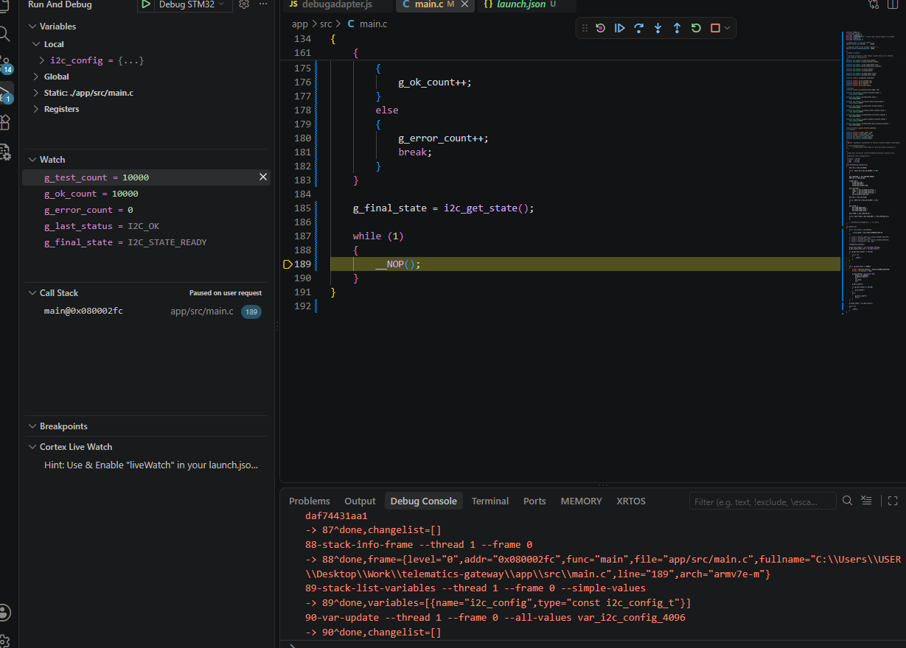
Figure 7. Test No. 8 final breakpoint: 10,000 attempted transfers, 10,000 successful transfers, zero errors, final status I2C_OK and final state I2C_STATE_READY.
TEST NO. 8 RESULT: PASS - 10,000 consecutive two-byte combined reads completed with zero recorded errors and the driver remained READY.

16.4 Interpretation and limitation
The result provides useful endurance evidence for repeated transaction admission, repeated-START operation, receive teardown, STOP completion, and state restoration. It does not replace long-duration environmental, EMC, clock-margin, or multi-master testing, and the DS3231 data values were not compared against a programmed reference timestamp on every iteration.

17. Test No. 9 - Invalid-parameter rejection

17.1 Objective
Verify that public I2C APIs reject invalid NULL data pointers before touching the bus and that these rejected calls do not corrupt the driver state.

17.2 Application-level calls
g_null_write_result =
i2c_write(DS3231_I2C_ADDRESS, NULL, 1U);
g_null_read_result =
i2c_read(DS3231_I2C_ADDRESS, NULL, 1U);
g_null_txrx_tx_result =
i2c_write_read(
DS3231_I2C_ADDRESS,
NULL,
1U,
rtc_data,
2U);
g_null_txrx_rx_result =
i2c_write_read(
DS3231_I2C_ADDRESS,
&register_address,
1U,
NULL,
2U);
g_state_after_parameter_tests = i2c_get_state();

17.3 Acceptance criteria and observed result
Variable / check | Expected | Observed
g_null_write_result | I2C_ERR_PARAM | I2C_ERR_PARAM
g_null_read_result | I2C_ERR_PARAM | I2C_ERR_PARAM
g_null_txrx_tx_result | I2C_ERR_PARAM | I2C_ERR_PARAM
g_null_txrx_rx_result | I2C_ERR_PARAM | I2C_ERR_PARAM
g_state_after_parameter_tests | I2C_STATE_READY | I2C_STATE_READY
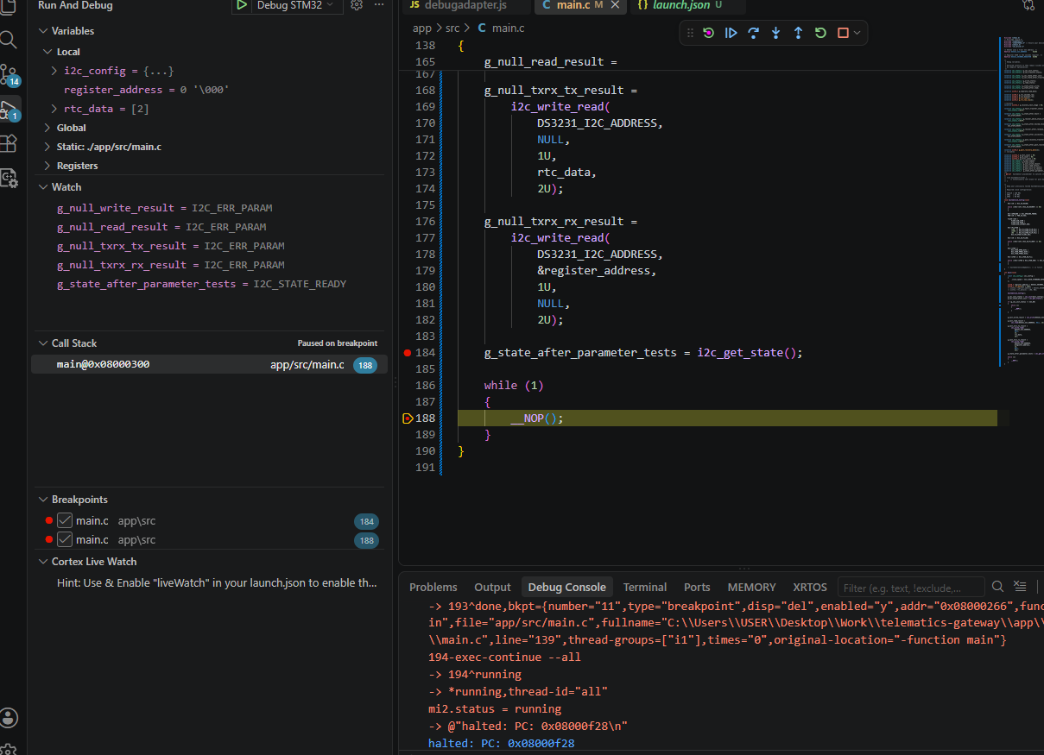
Figure 8. Test No. 9 final breakpoint: all four NULL-pointer requests returned I2C_ERR_PARAM and the driver state remained I2C_STATE_READY.
TEST NO. 9 RESULT: PASS - all tested NULL-pointer requests were rejected with I2C_ERR_PARAM and the driver remained READY.

17.4 Scope note
This test verifies the four NULL-pointer cases shown above. Zero-length requests, invalid 7-bit addresses, calls before initialization, explicit BUSY-state admission, and additional misuse cases were not separately executed in this campaign unless already exercised indirectly by another test.

18. Consolidated polling-driver verification result
The completed campaign provides a verified functional baseline for the current polling I2C1 driver. The following table is the authoritative pass/fail summary for this report.
Test | Verified behaviour | Final state / key result | Result
1 | Recoverable address NACK in combined transaction | NACK reported; READY restored | PASS
2 | Successful one-byte combined read | I2C_OK; READY | PASS
3 | Successful N-byte/seven-byte combined read | I2C_OK; READY | PASS
4 | Successful two-byte combined read | I2C_OK; READY | PASS
5 | Independent i2c_write() and i2c_read() | Both I2C_OK; READY | PASS
6 | Independent write/read address NACK recovery | Both NACK; READY preserved | PASS
7 | Physical SDA-low fault and runtime recovery | ERROR -> recovery -> READY -> I2C_OK | PASS
8 | 10,000 consecutive combined reads | 10,000 OK; 0 errors; READY | PASS
9 | NULL-pointer parameter validation | Four I2C_ERR_PARAM; READY | PASS
OVERALL POLLING-DRIVER VERDICT: PASS FOR THE EXECUTED TEST SCOPE.

19. Baseline disposition and next activity
The polling implementation should now be frozen and tagged as the known-good reference baseline before interrupt-driven development begins. The interrupt-driven implementation should preserve the verified public status codes and state semantics, then repeat the same functional and fault tests.
Recommended implementation order:
- Non-blocking interrupt-driven write.
- Interrupt-driven one-byte read.
- Interrupt-driven two-byte read.
- Interrupt-driven N-byte read.
- Combined write-read using repeated START.
- I2C1 event and error interrupt handling.
- Runtime recovery and regression of Tests No. 1 to No. 9.
Deferred evidence: a clean logic-analyser protocol capture and measured SCL timing remain valuable for later electrical verification, but no such capture is claimed as a passed result in this report.

